

**CryptoWebWeavers CAPSTONE PROJECT**

**Group 8:**

**Winnie Onduru**

**Jonathan Okwaro**

**Rael Ndonye**

**Bryson Shitsukane**

**Bernard Mucui**

**Judith Waguma**

**DATE OF SUBMISSION: 19th THURSDAY, OCTOBER 2023**

Table of Contents

Executive Summary: 6

Business Understanding: 8

Overview: 8

Problem Statement: 9

Project Objectives: 9

Metric of Success: 9

Data Understanding: 9

Exploring Data 11

Understanding the Dataset Dimensions: 11

Data Preparation: 11

Bitcoin Dataset Cleaning: 11

Data Quality Checks: 12

Feature Engineering: 12

Calculating Polarity Scores. 12

Feature Engineering on Text Data: 12

Exploratory Data Analysis (EDA): 13

Univariate Analysis 15

Distribution of the Sentiment Scores 16

Distribution of Comment and Post Scores 17

Summary Statists of the features and an overview of their distributions: 18

Frequency Distribution of the Top 10 Most Common Words: 18

Frequency Distribution of the Top Words by Sentiment Category 19

Distribution of the word "bitcoin" in Sentiment Categories 20

Distribution of the Top Titles 21

Bivariate Analysis 22

Visualizing Daily Average Sentiment Over Time 23

Visualizing the Distribution of Sentiment Scores Across Sentiment Categories 24

24

Multivariate Analysis 25

*Visualizing Average Sentiment and Post Score by Day of the Week:* 25

Relationship between Sentiment, Trading Volume, and Bitcoin Prices 26

Data Processing: 27

*Text Vectorisation:* 27

Methodology: 28

Modeling: 29

Multinomial Naive Bayes 29

Random Forest 30

XGBoost 32

LSTM (Long Short-Term Memory) 34

Transfer Learning (Transformers) 35

Why DistilBERT? 35

Deployment 37

Conclusions 37

Recommendations and Next Steps 37

References: 38

# Executive Summary:

This project has yielded significant insights and achievements, aligning with its primary objectives. The in-depth sentiment analysis of Bitcoin discussions on Reddit equips Binance Investment Group with a profound understanding of public sentiment regarding this critical cryptocurrency.

Through rigorous testing, DistilBERT has emerged as the optimal model, boasting a test accuracy of 88.11%. This model's reliability is instrumental for making informed investment decisions. While the LSTM model demonstrated potential, DistilBERT's outstanding performance makes it the clear choice for sentiment analysis.

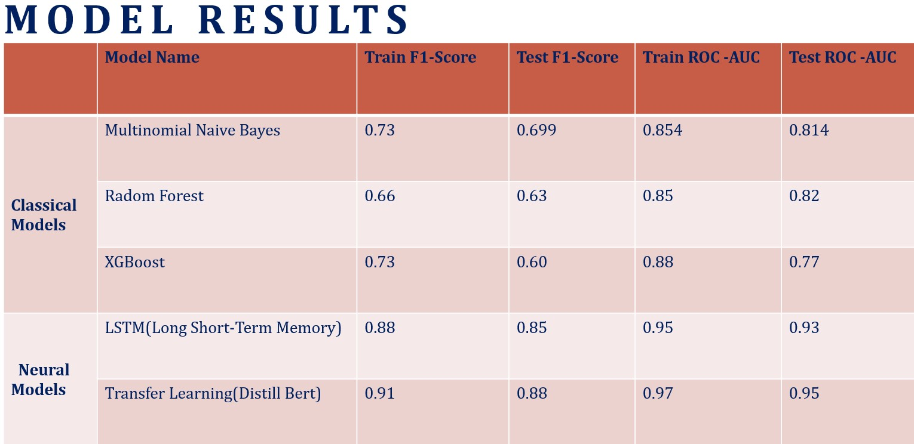

**Recommendations and Next Steps:**

To maintain the accuracy and effectiveness of sentiment analysis, we recommend regular model evaluations. These periodic assessments will ensure the model remains well-attuned to evolving sentiments. Incorporating feedback mechanisms to compare model predictions against actual market behaviors is crucial for refining the model and aligning it with investment strategies.

Additionally, diversifying sources of sentiment beyond Reddit discussions can provide a more holistic overview. Consistent performance checks and the inclusion of data from other platforms with significant Bitcoin discussions are essential.

To stay ahead in the ever-changing landscape, continuous learning, updating, and retraining of the DistilBERT model are recommended to ensure alignment with the latest discussions and market dynamics. These steps will enable Binance Investment Group to make more informed and agile investment decisions, fostering long-term success in the cryptocurrency market.

# Business Understanding:

## Overview:

Cryptocurrency an exciting, attention-grabbing, most trending financial product in the past years, has continued to waltz through the volatile financial space unperturbed. As the current rapid pace in technological advancements, Crypto is predicted to take the new place in the world`s financial system and in particular Bitcoin (BTC); the new money.

While many think crypto is just another phase in the financial space, others speculate that the phase has come to pass, citing the technology behind these new entrants like Bitcoin as very promising and possibly a disruptive innovation for the future. The spike in popularity therefore is only an indication of the increasing appetite in understanding how investor sentiments impacts the market.

Founded in 2009, the first crypto to be established was Bitcoin, and it has fortified its space as the best known crypto. Investors can make short term investments due to the volatility of the market or hold their investments until that time when the value skyrockets. The volatility of this digital market environments is the main drive that spikes the rush making it interesting and appealing to investors wanting to trade. The online hullabaloo alone can cause the prices to increase tenfold or plummet, and thus this is the drive behind the crypto sentiment analysis predicting the market trends.

A lot of risks within cryptocurrencies are bound to emotions, group 8 members therefore believe that researching the best models is relevant, because of the potential cryptocurrencies have in the modern-day financial system.

Therefore, CryptoWebWeavers project aims to create a sophisticated model system that empowers cryptocurrency investors with a data-driven approach for making informed investment decisions in the volatile Bitcoin (BTC) market.

The motivation behind this project is twofold.

* Firstly, the cryptocurrency market, particularly Bitcoin, has witnessed significant growth and attracted considerable interest from investors worldwide. However, its inherent volatility and complex nature makes it challenging to navigate without data-driven insights.
* Secondly, the project addresses the growing need to harness the power of data analytics and sentiment analysis to thrive in the evolving landscape of digital currencies.

On Reddit, one of the world's largest online platforms, Bitcoin is a focal point of intense debate and speculation. Through the multitude of comments from posts, users express sentiments ranging from optimism and scepticism to curiosity and criticism. By harnessing and analysing this sentiment data from Reddit, we gain a comprehensive understanding of public perception and sentiment trends related to Bitcoin.

## Problem Statement:

For "***Binance Investment Group***", understanding how people feel about Bitcoin on platforms like Reddit provide early hints about market changes. This can help decide where to invest or when to pull out. Negative feelings might not always be bad; they could be opportunities to invest differently.

This sentiment data also helps the group communicate better with clients, addressing their specific concerns. Overall, by paying attention to public sentiment, the group can make smarter decisions in the unpredictable world of cryptocurrencies.

## Project Objectives:

* To monitor and analyse sentiments about Bitcoin on primary platforms like Reddit and capture the essence of public opinion.
* To implement advanced machine learning and deep learning models, ensuring precise and reliable sentiment prediction.
* To shape communication methods in line with prevailing sentiments, ensuring client apprehensions are comprehensively addressed.
* To infuse sentiment insights into the group's decision-making process, fortifying strategies in the unpredictable cryptocurrency realm.

## Metric of Success:

* **ROC-AUC score:**

For gauging the overall predictive power of our final model.

* **F1-score**

**Minimizing False Positives:** Minimizing false positives means you are cautious about making an investment decision unless you are highly confident that a trading signal is accurate. This approach minimizes the risk of entering trades that don't perform as expected.

**Minimizing False Negatives:** Minimizing false negatives means you are more open to taking trading positions, even if there's a chance of some signals being inaccurate. This approach helps to capture more potential profit opportunities.

**Minimizing False Positives:** Minimizing false positives means you are cautious about making an investment decision unless you are highly confident that a trading signal is accurate. This approach minimizes the risk of entering trades that don't perform as expected.

**Minimizing False Negatives:** Minimizing false negatives means you are more open to taking trading positions, even if there's a chance of some signals being inaccurate. This approach can help you capture more potential profit opportunities.

# Data Understanding:

Our first dataset was obtained from [SocialGrep](https://socialgrep.com/datasets/reddit-r-bitcoin-data-for-jun-2022).

**Reddit_Comments:**

**This dataset captures public sentiment through comments in the Bitcoin subreddit for June 2022. With 170,032 individual comments, it offers a granular view of public discussions and reactions related to Bitcoin in this specific month.**

**Contains data related to Reddit comments in the r/Bitcoin subreddit, with columns:**

* type: Type of the data (in this case, "comment").
* id: Unique identifier for the comment.
* subreddit.id and subreddit.
* subreddit.name - The name of the subreddit. (String)
* subreddit.nsfw - Whether the subreddit is NSFW. (Boolean)
* created_utc: UTC timestamp for when the comment was created.
* permalink: Link to the comment on Reddit.
* body: The text content of the comment.
* sentiment: Sentiment score of the comment.
* score: The score (upvotes minus downvotes) of the comment.

Our second dataset was also obtained from [SocialGrep](https://socialgrep.com/datasets/reddit-r-bitcoin-data-for-jun-2022).

**Reddit_Posts:**

**This dataset comprises 7,541 posts from the Bitcoin subreddit for June 2022. It provides insights into the main topics, discussions, and sentiment concerning Bitcoin during this month.** **Contains data related to Reddit posts in the r/Bitcoin subreddit, with columns:**

* type: Type of the data (in this case, "post").
* id: Unique identifier for the post.
* subreddit.id and subreddit.name: Information about the subreddit.
* created_utc: UTC timestamp for when the post was created.
* permalink and domain: Links related to the post.
* url: URL of the post.
* selftext: The text content of the post.
* title: The title of the post.
* score: The score (upvotes minus downvotes) of the post.

Our third dataset was obtained from [Kaggle](https://www.kaggle.com/datasets/sudalairajkumar/cryptocurrency-historical-prices-coingecko/versions/57?resource=download&select=bitcoin.csv)

**Bitcoin_Prices:**

**This dataset provides a historical view of Bitcoin's market metrics spanning from January 1, 2015, to November 16, 2022. It contains data on Bitcoin's price, trading volume, and market capitalization across 2,876 records.** **Data columns:**

* date: The date of the data.
* price: The price of Bitcoin on that day.
* total_volume: The total trading volume of Bitcoin on that day.
* market_cap: The market capitalization of Bitcoin on that day.
* coin_name: The name of the cryptocurrency (which is Bitcoin for all rows).

## Exploring Data

We initiated the project by downloading the necessary libraries. Then created a data frame for the comments. Upon initial inspection of the comments data frame data:

* The body column appeared to contain textual content of the comments, which was vital for our sentiment analysis.
* We inspected the sentiment column, already showing potential of containing pre-computed sentiment scores that we needed to verify and potentially use in our analysis.
* Further exploration and cleaning were deemed necessary to handle missing or irrelevant entries, especially in the body column where our textual analysis focused on.

### Understanding the Dataset Dimensions:

The comments data frame dataset contained 170,032 rows and 10 columns. Each row represented a unique comment, and the columns represented various attributes of the comments such as the textual content, sentiment score, and additional metadata. The team noted, that a detailed data dictionary or exploration of unique values in each column would further enlighten the understanding of the available data.

Next, the team loaded the posts data frame dataset which contained information about various posts, from the reddit platform. This data offered insights into the primary topics of discussion and potentially correlation with user sentiment as expressed in the comments.

## Data Preparation:

### Bitcoin Dataset Cleaning:

* Merging Comments and Posts Datasets:
  + - In order to thoroughly examine user discussions in relation to Bitcoin's market performance, the team combined the comments and posts datasets. The resulting dataset, named 'merged_df,' formed the foundation for our analysis, enabling us to explore possible connections and trends between user sentiment and Bitcoin's market characteristics.
* After merging the data set, we now were able to obtain a DataFrame that contained both comments and posts, and ensured that the merge was done correctly without losing or duplicating data, then performed a thorough quality check of the merged data. Subsequent analyses explored how sentiments and topics discussed in the comments correlated with the market behaviour of Bitcoin.

### Data Quality Checks:

* The team checked the shape of the merged data to understand the available data points.
* Examined the data for missing values in each column and evaluated the need for handling them in the subsequent analysis.
* To ensure the reliability of our subsequent analysis, we performed the following data cleaning steps:
  + - Dropped rows with missing ***`sentiment´*** values as these were crucial for our sentiment analysis.
    - Filtered out rows where the `***body´*** of the comment is ***'[deleted]'*** or '***[removed]'*** to ensure the quality and authenticity of the textual data utilized in the analysis.
* After performing the data cleaning steps, we validated the operations by:
  + - Checking for missing values to ensure all necessary cleaning has been applied.
    - Also checked to confirm for any duplicates.
    - The data contained no duplicate entries, ensuring that our analysis would not be skewed in any way.
    - The cleaned data now contained ***136,845 rows*** and ***9 columns***, a substantial amount of data for our analysis.

## Feature Engineering:

In this section, we delved into the p feature engineering, a critical step in refining our dataset to uncover deeper insights.

### Calculating Polarity Scores.

* + - A key aspect of the feature engineering was to calculate the sentiment scores.

The Team used ***VADER sentiment intensity analyzer***, which is best fitted for social media text to compute sentiment scores for each comment. These sentiment scores provided a compound value summarizing the overall sentiment of the text. Following this, we classified the derived sentiment into ***'positive,' 'neutral,'*** or ***'negative'*** categories, enhancing our following analysis.

The main aim of calculating polarity scores was to compare our scores with the already calculated scores on the sentiment column to see if they do match; and indeed, they matched.

### Feature Engineering on Text Data:

We defined a comprehensive text cleaning function and called it ***enhanced_clean_text***. The overview and the logic behind each step of the function included:

**Convert to Lowercase:**

* + - To ensure consistency and to prevent the model from treating the same words in different cases as distinct.

**Handle URLs:**

* + - Removed URLs since they don’t convey useful information for sentiment analysis.

**Handle Numbers:**

* + - Excluded numbers for lack of relevance, in understanding the sentiment in the text.

**Handle Mentioned Usernames:**

* + - Removed mentioned usernames as they were more of identifiers than informative for sentiment analysis.

**Expand Contractions:**

* + - Expanded the contractions, this aids in having a standardized set of words to work with.

**Tokenization:**

* + - Separated the text into words, making it easier to perform subsequent cleaning steps on individual words.

**Removed Stopwords and Perform Lemmatization:**

* + - Excluded common words (stopwords) and reduced words to their base or root form (lemmatization) to focus on key

words that saved us computational resources.

**Removing Short Words:**

* + - Excluded short words with little or no significant meaning for analysis.

# Exploratory Data Analysis (EDA):

Data Exploration and Insights

In the initial phase of our data exploration, we performed an Exploratory Data Analysis (EDA), a process that involves a systematic and comprehensive examination of our dataset to uncover hidden patterns, relationships, and insights. EDA serves as the foundation upon which our data-driven decisions are built, allowing us to gain a deep understanding of the data's characteristics.

As we traversed through the data to mine valuable insights, one of the techniques we employed was the creation of word clouds. These word clouds offer a visual representation of the most frequent words or phrases within our data, providing a quick and intuitive way to grasp the prominent language patterns and themes.

We examined word clouds to offer visual representations of different sentiment categories, to determine predominant words or phrases and potential topics discussed positively, negatively, or neutrally in the community, thus providing a quick and intuitive way to grasp the language patterns and themes.

Word clouds for comments were categorized as 'positive', 'negative', and 'neutral’ and visualized separately to gain insights into the language and topics associated with each sentiment category.

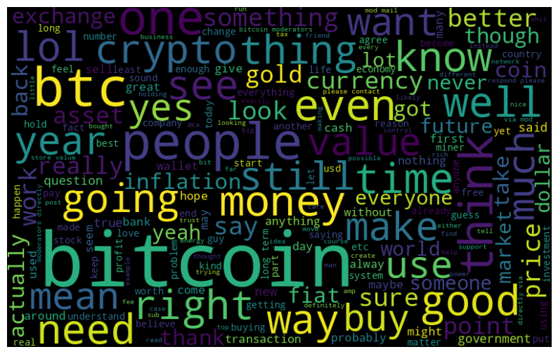

Figure 1_ Positive Words

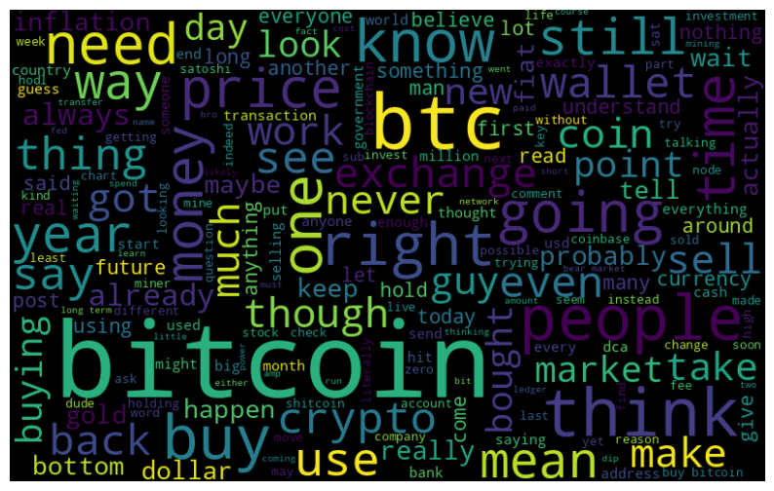

Figure 2_ Neutral Words

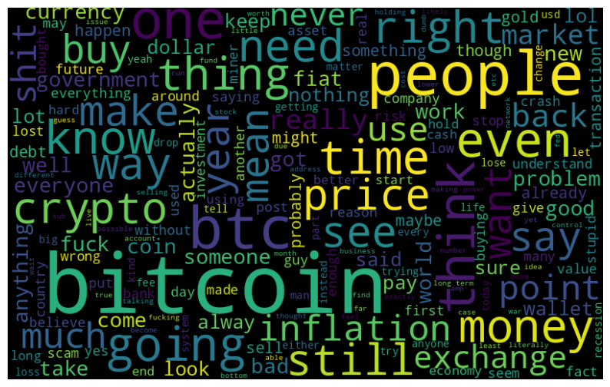

Figure 3_ Negative Words

## Univariate Analysis

Univariate analysis explores one variable at a time, providing insights into its distribution, central tendency, dispersion, and shape.

In this section, we delved into the univariate analysis of various variables within our dataset, exploring their distributions, identifying prevalent patterns, and making initial observations on their characteristics. The variables might include numerical features, such as sentiment scores, and categorical features, such as sentiments categories or specific words.

This form of analysis was crucial for:

* + - Understanding the basic characteristics, tendencies, and patterns within individual variables.
    - Identifying outliers or anomalies that might warrant further investigation.
    - Facilitating the selection and engineering of features in subsequent modeling stages.

### Distribution of the Sentiment Scores

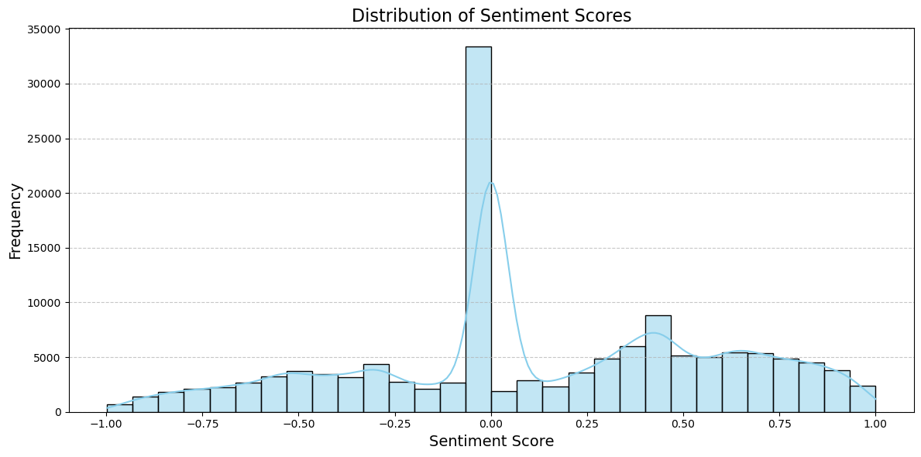

From the plot, we observed:

* + Most comments have a sentiment score of 0, indicating a neutral sentiment.
  + There is a significant number of negative comments between 0 and -1.
  + Similarly, there is a good number of positive comments between 0 and 1.

### Distribution of Comment and Post Scores

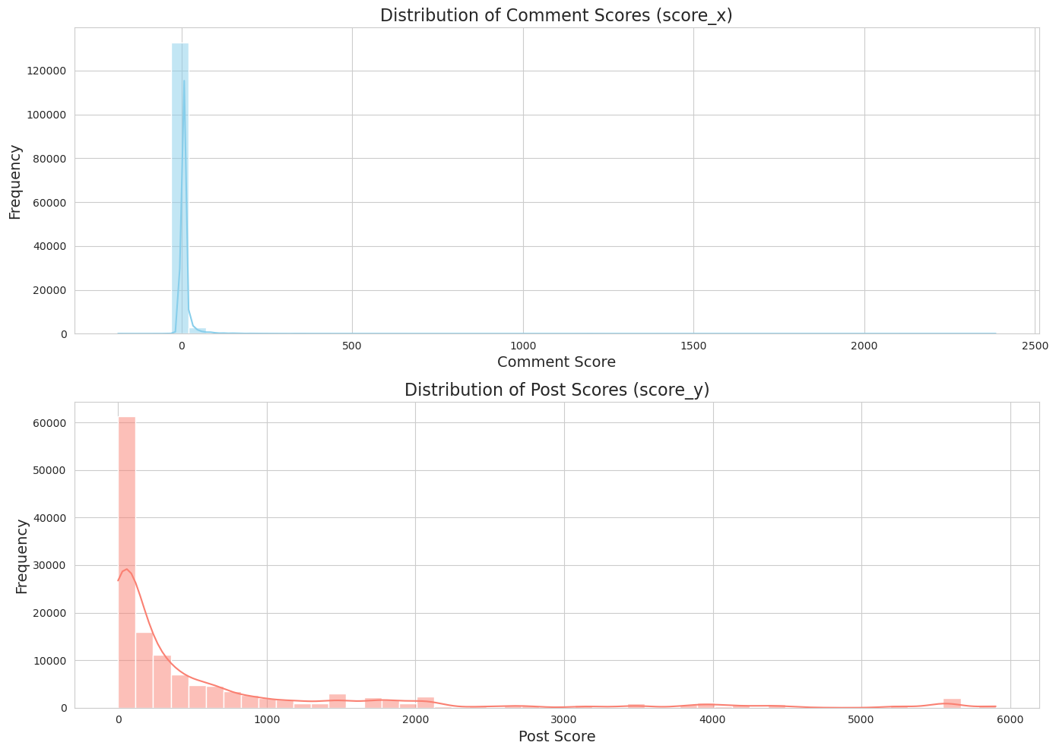

The histograms above provide insights into the distributions of comment and post scores:

* + - ***Comment Scores (score_x):*** Most of the comments have scores close to 0, with a few exceptions that have higher scores. The distribution appears to be right-skewed, meaning there are a few comments with exceptionally high scores.
    - ***Post Scores (score_y):*** Similar to comment scores, most of the posts have scores close to 0, but there are some with higher scores. This distribution is also right-skewed.

### Summary Statists of the features and an overview of their distributions:

In the dataset, provided, we had two score features: ***score_x*** and ***score_y***, which we possibly felt held different scoring metrics related to the posts and comments. Understanding the distribution, central tendency, and spread of these scores provided insights into:

* + - The general trend of scoring within the community.
    - The presence of any outliers or abnormal scoring patterns.
    - Potential correlations or disparities between ***score_x*** and ***score_y.***

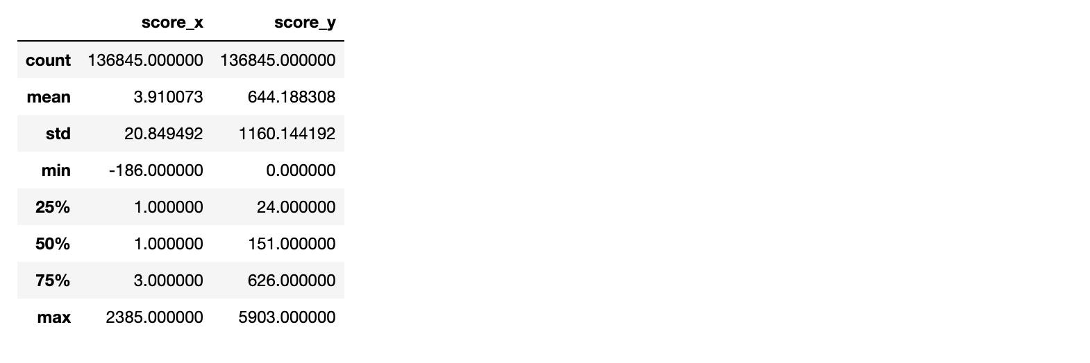

Figure 4_ Summary Statistics

***Comment Scores (score_x):*** **Medians & Quartiles**: Half of the comments have scores of 1 or less. 75% of the comments have scores of 2 or less, indicating that very few comments received exceptionally high scores.

***Post Scores (score_y):*** **Medians & Quartiles**: Half of the posts have scores of 151 or less. 75% of the posts have scores of 626 or less, suggesting a few posts receive exceptionally high scores.

### Frequency Distribution of the Top 10 Most Common Words:

To comprehend the prevalent words and potential topics of discussion within the comments, the team calculated the frequencies of each unique word.

This analysis aimed at:

* + - Identifying the most frequently occurring words, an indication of popular themes or subjects in the community discussions.
    - Provided a foundation for subsequent analyses related to word prevalence, such as visualizing common words or exploring their association with sentiments.

We pursued this through:

* + - Tokenizing the text data into individual words.
    - Calculating the frequency of each unique word using the Counter class.

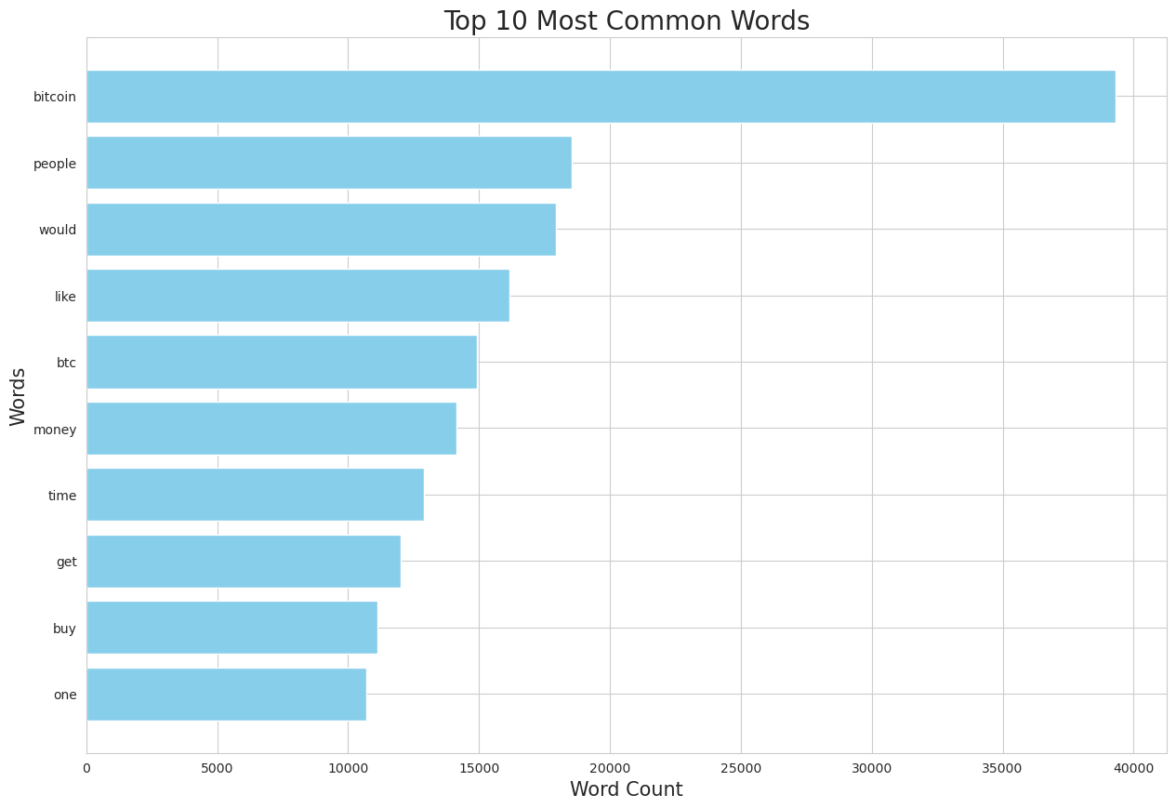

Figure 5_ Top 10 Most Common Words

### Frequency Distribution of the Top Words by Sentiment Category

To gain deeper insights into the language and terminologies prevalent within each sentiment category, we segregated the comments into 'positive', 'negative', and 'neutral' based on their sentiment categories, and analysed the word frequencies within each group.

This analysis enabled us to:

* + - Understand the most common words within each sentiment category, potentially highlighting words that might be indicative or characteristic of the sentiment.
    - Compared the prevalent words across different sentiment categories to identify unique and common terminologies.

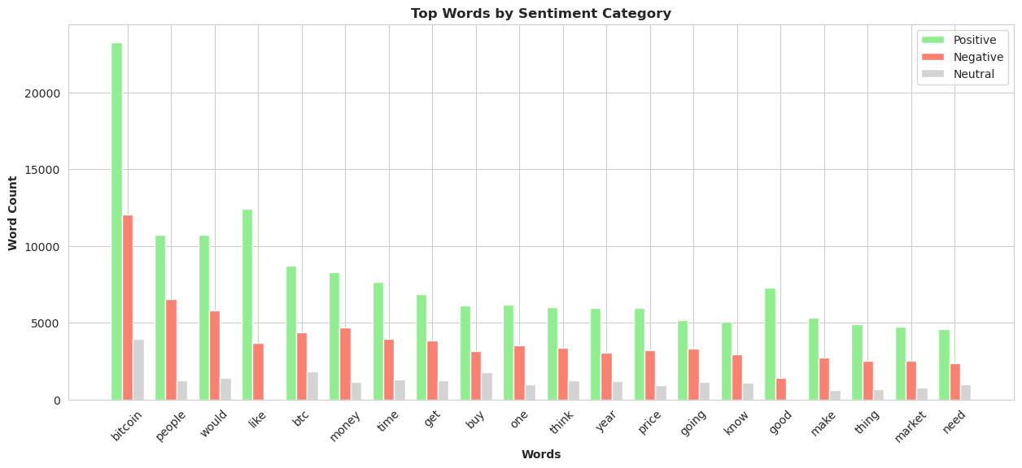

Figure 6_Top Word by Sentiment Category

* + - The bar chart represents the top words and their frequencies within positive, negative, and neutral sentiment categories.
    - Certain words like bitcoin, money, and time appear prominently across different sentiment categories, potentially indicating general themes in the discussions.
    - Some words are more prevalent in a particular sentiment category, indicating a possible association with that sentiment.

### Distribution of the word "bitcoin" in Sentiment Categories

We wanted to understand the insights and its prevalence of `***bitcoin´*** within different sentiment categories. This visualization aimed to:

* + - Identify the frequency of the term ***"bitcoin"*** within positive, negative, and neutral comments.
    - Provided insights into whether discussions involving ***"bitcoin"*** were predominantly positive, negative, or neutral.

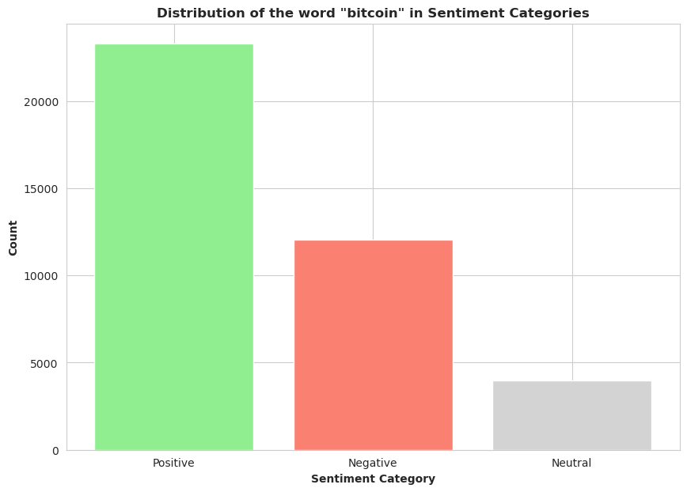

Figure 7_Distribution of the word "bitcoin" in Sentiment Categories

* + - The bar chart showcases the counts of the word "bitcoin" within positive, negative, and neutral sentiment categories.
    - The term "bitcoin" appears across all sentiment categories, indicating its significance within the community discussions.
    - By comparing the counts, we can note that the word "bitcoin" is more predominantly seen in a positive light, as compared to the negative, and neutral sentiments.

### Distribution of the Top Titles

Understanding the most prevalent titles in the discussions offers insights into topics that garner significant attention or are widely discussed within the community.

Visualizing the top titles and their counts enabled us to:

* + - Identify the titles frequently occurring, potentially indicating popular or recurring topics.
    - Understand the breadth of discussions and themes prevalent within the dataset.

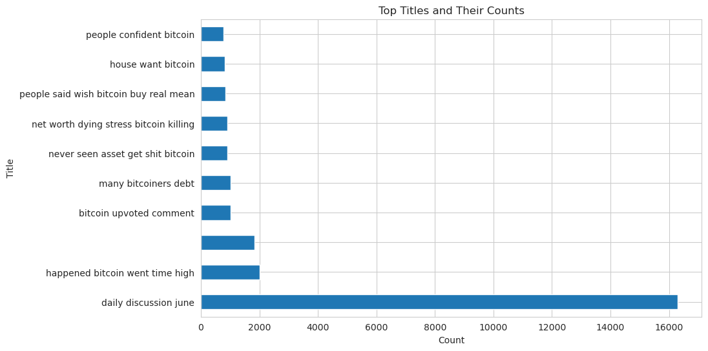

Figure 8_Top Titles And Their Counts

* + - The bar chart depicts the top titles and their respective counts, providing a visual understanding of the most discussed titles within the dataset.
    - Titles such as ***'daily discussion june',*** ***'happened bitcoin went time high'***, and ***'bitcoin upvoted comment'*** appeared to be quite prevalent, indicating them as notable topics of discussion within the community.
    - Understanding the contexts and sentiments associated with these prevalent titles might offer deeper insights into the nature and themes of the discussions.

## Bivariate Analysis

The team performed bivariate analyses to explore the relationships and interactions between different pairs of variables within our dataset. These analyses involved exploring associations between sentiment scores and other variables, investigating how sentiments and discussions evolved over time, and examined how different variables might interplay with each other within different contexts or conditions.

Bivariate analysis provided insights into:

* + - Potential correlations or associations between variables.
    - Identified patterns or trends occurring between variable pairs.
    - Exploring how variables might influence each other within different contexts or conditions.

### Visualizing Daily Average Sentiment Over Time

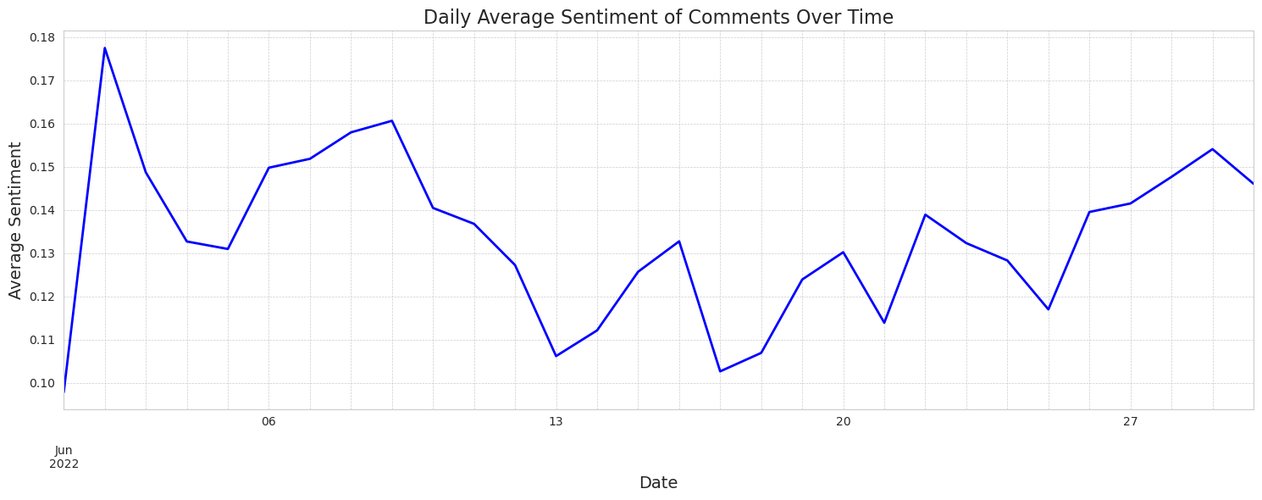

Figure 9_Daily Average Sentiment of Comments Over Time

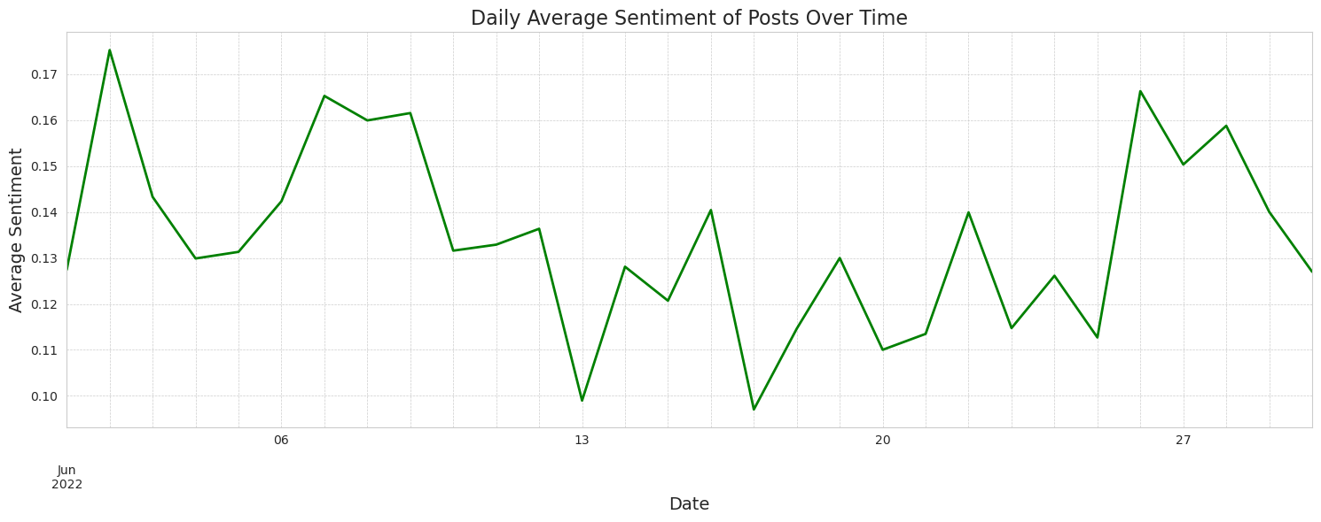

Figure 10_Daily Average Sentiment of Posts Over Time

* + - The line plots represent temporal trends in the daily average sentiment for comments (blue line) and posts (green line), providing a visual representation of the fluctuations in sentiment over time.
    - Peaks and troughs in the line plots might correspond to specific events or discussions that influenced the sentiments within the community.
    - Comparing these trends with external events, market behaviours, or internal discussions might offer deeper insights into factors influencing the sentiments.

### Visualizing the Distribution of Sentiment Scores Across Sentiment Categories

### 

Figure 11_Distribution of Sentiment Scores by Sentiment Category

* + - The boxplot provides visual representation of the distribution of sentiment scores across the ***Positive***, ***Negative***, and ***Neutral*** sentiment categories.
    - Observations on the median (central line within the box), interquartile range (height of the box), and potential outliers (points beyond the whiskers) can be noted for each sentiment category.
    - Specific observations related to the spread and outliers within each category, and comparisons across categories, provide insights into the nature and variability of sentiments within the discussions.

## Multivariate Analysis

The team conducted a multivariate analysis to explore relationships, patterns, and interactions between multiple variables simultaneously. We delved into various multivariate analyses, exploring how different features interact with each other and potentially influence sentiments and discussions within the community.

This involved exploring temporal trends involving multiple variables, investigating associations between words, sentiments, and other features.

Engaging in multivariate analysis allowed us to:

* + - Examine the interactions and associations between different features.
    - Investigate how multiple variables influence each other and potentially affect sentiments.
    - Explore complex patterns and structures within the data that might not have been discernible through univariate or bivariate analyses.

### *Visualizing Average Sentiment and Post Score by Day of the Week:*

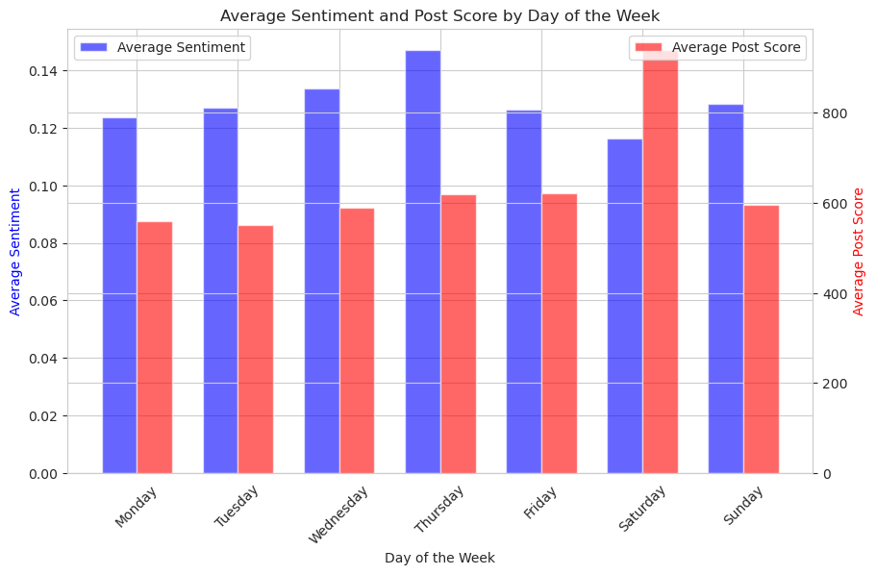

#### Figure _Average Sentiment and Post Score by Day of The Week

* + - The bar plot represents the average sentiment and post score across different days of the week, revealing any weekly trends in the data.
    - Observations on whether certain days consistently exhibit higher or lower average sentiments and post scores can be drawn from the plot.
    - Any discernible patterns that suggest a weekly cycle in sentiment or post popularity can be noted and further explored.

### ****Relationship between Sentiment, Trading Volume, and Bitcoin Prices****

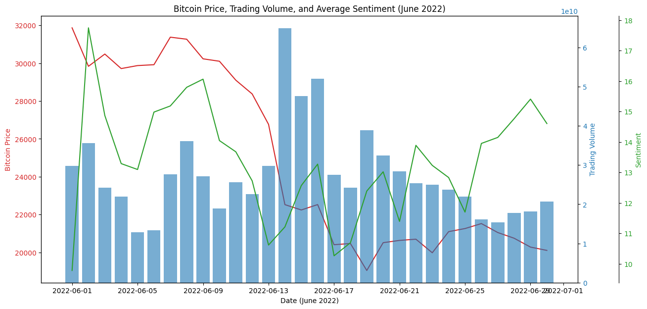

Figure _Bitcoin Price, Trading Volume and Average Sentiment_June2022

**Sentiment and Price Correlation:** There's a discernible correlation between sentiment and Bitcoin price throughout the month of June. On days when the sentiment is positive, the Bitcoin price tends to rise. Conversely, when the sentiment dips into negative territory, the Bitcoin price often shows a decline. This suggests that public sentiment can be a good indicator of price movement, or vice versa.

**Trade Volume Observations:** Significant trading volumes, as depicted by taller blue bars, often coincide with notable changes in sentiment and price. This is expected, as heightened trading activity often reflects a reaction to prevailing sentiments or significant price movements.

## Data Processing:

CryptoWebWeavers team focused on pre-processing the data, ensuring it was cleaned, structured, and formatted appropriately for subsequent analyses and modeling. We engaged in various data pre-processing steps, such as label encoding the target variable, normalizing numerical variables, and engineered new features to enhance our analyses and models.

Effective data pre-processing is vital for:

* + - Ensuring the quality and accuracy of the data, mitigating any issues related to missing, inconsistent, or outlier values.
    - Preparing and engineering features that can effectively contribute to subsequent analyses and predictive modeling.
    - Enhancing the performance and accuracy of any applied machine learning models.

### *Text Vectorisation:*

For proper, effective analysis and modeling of textual data, it was paramount to convert the text into numerical formats that can be interpreted and processed by machine learning algorithms.

#### The Techniques; We implored the following techniques.

TF-IDF Vectorization ***(Term Frequency-Inverse Document Frequency);***

This technique converted the text data into numerical vectors, emphasizing on words that were unique to particular documents.

* + - The TF-IDF vectorization method, transformed the text data into numerical vectors while considering the importance of each term in relation to the entire dataset based on its uniqueness.
    - The terms ***TF (Term Frequency)-*** Measured the frequency of words in the document and the ***Inverse Document Frequency (IDF)***: Dampened the weight of words that occurred frequently across all documents.

***The Results:***

* + - After initialising the `***TfidfVectorizer***´ and applying it to the `***cleaned_body´*** text data, and transforming it into a sparse matrix of TF-IDF vectors, as opposed to converting the sparse matrix into a dense format assumed to consume a lot of memory for a large dataset, we instead used the vectors as a sparse matrix.
    - This saved memory by only storing the non-zero parts of our feature vectors.
    - We then set the parameters, limiting output to top 5000 most frequent terms in the vectorized output.
    - In subsequent steps, the TF-IDF vectors served as input features for our models, while exploring the relationship between text data and target variables.

Word2Vec Embeddings***;***

Generates dense vector representations of words, capturing semantic meanings based on contextual usage. Word2Vec is a word embedding technique that represents words in dense vector spaces. The model learns to associate words based on contextual usage, capturing semantic meanings and relationships between words.

We leveraged the Word2Vec model to:

* + - Convert words in our corpus into vector representations that capture semantic meanings.
    - Explore semantic relationships and similarities between different words in the corpus.

Thereafter, we implemented and trained a Word2Vec model to generate word embeddings for our textual data by:

* + - **Tokenization:** The cleaned text data is tokenized into words, forming the input for the Word2Vec model.
    - **Word2Vec Training**: The model is trained on the tokenized text, learning to represent words as vectors based on their contextual usage.
    - ***Document Vectors:*** We calculated a vector for each document by averaging the Word2Vec vectors of all words in the documents.

#### Doc2Vec Embeddings:

After exploring Word2Vec embeddings, we embarked on to ***Doc2Vec*** – a model that generates vector representations for entire documents or sentences. The implementation of Doc2Vec allowed the team to capture the semantic meanings and relationships within the entirety of the text data, which was utilized for further semantic analysis and modeling.

We therefore.

* + - Tokenized the cleaned text into words, which served as input for the Doc2Vec model.
    - Created tagged documents, associating each document with a unique tag/identifier.
    - Trained the Doc2Vec model on our text data.
    - Inferred document vectors for our corpus using the trained model.

With the Data Frame, ` doc2vec_df` holding the Doc2Vec embeddings of the documents in our dataset, each row represented a document and columns represented the dimensions of the embedding space, giving us a total of **136,845** documents, each represented by a 100-dimensional vector.

# Methodology:

Having meticulously pre-processed our data and engineered valuable features, we transitioned modeling our analysis. In this section, we worked on building and evaluating models using diverse feature sets:

* + - TF-IDF,
    - Word2Vec embeddings, and
    - Doc2Vec embeddings.

Our objective was to leverage these features to build models that can accurately analyse and predict aspects of our text data. We explored different applications of various machine learning and deep learning algorithms, each providing unique approaches and capabilities in handling text data.

## Modeling:

Through the utilization of algorithms, we explored, analysed, and compared performances and capabilities in modeling our text data. We further delved deep into implementation, tuning, and evaluation of these models, extracting insights and identifying models that offer optimal balance of performance and interpretability.

To streamline the modeling process, we defined a function `***train_and_evaluate***´ to facilitate the training and evaluation of the models with various feature sets ***(tfidf_df, word2vec_df, and doc2vec_df***) and different machine learning algorithms. This function enhanced the efficiency and consistency of the modeling process, ensured models were trained and evaluated under uniform conditions, thereby enhancing the validity of our comparative analyses.

This function was crafted to handle:

* + - **Data Splitting:** Segmenting data into training and testing sets.
    - **Model Training**: Fitting the model on the training data.
    - **Predictions:** Generating predictions on both training and testing data.
    - **Evaluation:** Assessing the model performance using various metrics (Accuracy, F1 Score, ROC-AUC Score).
    - **Classification Reports**: Providing detailed performance reports for each class.
    - **Metrics Storage**: Compiling the metrics in a structured format for further analysis and comparison.

We explored the application of various machine learning and deep learning algorithms, each providing unique approaches and capabilities in handling text data:

### Multinomial Naive Bayes

A probabilistic classifier that leverages Bayes' theorem, adept for classification tasks with discrete features like text data.

The Multinomial NB served as a baseline as we explored additional models and feature sets, allowing for comparative analysis to identify the most effective modeling approach for our data.

Additionally, MultinomialNB inherently does not accommodate negative values, which are present in the word2vec_df and doc2vec_df dataframes. Therefore, the team skiped modeling these two feature sets with the MultinomialNB model.

* **Accuracy:**
  + The accuracy metric provides a straightforward measure of the overall correctness of the model's predictions. The small difference between training and testing accuracy suggests that the model is somewhat fit to the training data.
    - **Train Accuracy**: 73.27%
    - **Test Accuracy**: 69.68%
* **F1 Score:**
  + The F1 Score balances precision and recall, reflects the model’s capability to maintain a harmonious trade-off between false positives and false negatives. A relatively high F1 score both for the train and test sets indicates that the model manages to achieve a reasonable balance.
    - **Train F1 Score**: 73.39%
    - **Test F1 Score:** 69.86% ROC-AUC Score:
* **ROC-AUC Score:**
  + The ROC-AUC Score signifies the model's ability to distinguish between the different sentiment classes. A score above 80% for both training and testing data suggests that the model has a good discriminative power, and the small gap between training and testing scores indicates a somewhat good fit to the training data.
    - **Train ROC-AUC Score: 85.40%**
    - **Test ROC-AUC Score: 81.43%**

**Key Takeaway:**

* + - The model exhibits fair performance across metrics and is somewhat well fit to the data, as indicated by the small discrepancies between training and testing scores.

### Random Forest

Random Forest, being an ensemble learning method, combines multiple decision trees to enhance predictive accuracy and control over-fitting. Given its ability to handle high-dimensional datasets and provide interpretability through feature importance, Random Forest appeared to be a compelling model for exploration in the context of our sentiment classification task.

We implored the Random Forest model by:

* + - Utilizing the ***train_and_evaluate*** function to train the Random Forest model with TF-IDF features.
    - Analysed various performance metrics to assess the model's predictive capabilities and generalization to unseen data.

#### Using the TD-IDF Features.

Performance

* **Accuracy:**

The accuracy reveals a strong performance on training data but a significant drop in the testing data, indicating potential overfitting

* + - **Training**: 99.50%
    - **Testing:** 81.22%.
* **F1 Score**:

The F1 Score, balancing precision and recall, reflects the model’s efficacy in managing false positives and negatives, with a notable discrepancy between training and testing scores, also indicating potential overfitting.

* + - **Training:** 99.50%
    - **Testing:** 81.00%
* **ROC-AUC Score:**

The ROC-AUC Score underscores the model's discriminative power, revealing a potent ability to differentiate between sentiment classes, albeit with room for improvement in generalization.

* + - **Training:** 99.87%
    - **Testing:** 91.16%

While the Random Forest model demonstrates robust predictive capabilities, especially in discriminating between sentiment classes, the noticeable discrepancies between training and testing metrics underscore a need to address overfitting in subsequent model iterations.

#### Word2Vec Features:

The team explored additional features with Random Forest. We trained the Random Forest model with Word2Vec features, using the `***train_and_evaluate***´ function.

Performance:

* **Accuracy:**

The significant discrepancy between training and testing accuracy highlights a substantial overfitting issue.

* + - **Training**: 99.81%
    - **Testing:** 62.38%
* **F1 Score**:
  + - Training: 99.81%
    - Testing: 62.17% The F1 Score exhibits a similar pattern, indicating substantial overfitting.
* **ROC-AUC Score:**

Although the ROC-AUC Score remains high, indicating strong discriminative power, the drop in testing score aligns with the observed overfitting pattern.

* + - **Training:** 99.91%
    - **Testing:** 78.77%

#### Doc2Vec Features

The team train ed and evaluated the Random Forest model using Doc2Vec features and the train_and_evaluate function.

Performance:

* **Accuracy:**

The model exhibits perfect accuracy on the training data but struggles with the testing data, indicating a significant overfitting scenario.

* + - **Training:** 100%
    - **Testing:** 57.90%
* **F1 Score:**

The F1 Score, reflect the balance between precision and recall, showcases a similar pattern, further highlighting the overfitting issue.

* + - **Training:** 100%
    - **Testing:** 57.14%
* ROC-AUC Score:

The ROC-AUC Score showed significant overfitting.

* + - **Training:** 100%
    - **Testing**: 73.66%

**Key Takeaway:**

* + The Random Forest model, while demonstrated exceptional performance on the training data, also indicated significant overfitting, as evidenced by the drastic drop in testing metrics.
  + Future iterations should explore strategies like hyperparameter tuning and regularization to mitigate overfitting and enhance generalization.

### XGBoost

XGBoost is an optimized distributed gradient boosting library designed to be highly efficient, flexible, and portable.

|  |  |
| --- | --- |
| Features Employed | Observed Performance |
| **TF-IDF Features:** The ROC-AUC Score is high, indicating strong discriminative power between sentiment classes. | **Accuracy:** The model exhibits robust accuracy on both training and testing data, indicating a reasonably good fit.   * + **Training:** 77.91%   + **Testing:** 74.87% |
| **F1 Score:** The F1 Score reflects a balance between precision and recall, showcasing a good performance.   * + **Training:** 77.94%   + **Testing:** 74.73% |
| **ROC-AUC Score:** The ROC-AUC Score is high, indicating strong discriminative power between sentiment classes   * + Training: 91.45%   + Testing: 89.05% |
| **Word2Vec Features;** we implemented XGBoost model using Word2Vec features and the train_and_evaluate function. | **Accuracy:** The model exhibits moderately good accuracy on the training data and a reasonable performance on the testing data.   * + **Training:** 74.90%   + **Testing:** 63.85% |
| **F1 Score:** The F1 Score reflects a balance between precision and recall, showcasing a moderately good performance   * + **Training:** 75.01%   + **Testing:** 64.06% |
| **ROC-AUC Score:** The ROC-AUC Score remains high, indicating strong discriminative power between sentiment classes.   * + **Training: 90.24%**   + **Testing: 81.29%** |
| **Doc2Vec Feature:** Implemented XGBoost model using Doc2Vec features and the train_and_evaluate function. | **Accuracy:** The model exhibits good accuracy on the training data but reveals a significant drop in accuracy on the testing data, indicating potential overfitting.   * + **Training:** 73.47%   + **Testing:** 60.29% |
| **F1 Score:** The F1 Score reflects a balance between precision and recall, showcasing a good performance on the training data but a significant drop on the testing data, also denoting potential overfitting.   * + **Training:** 73.73%   + **Testing:** 60.47% |
| **ROC-AUC Score:** The ROC-AUC Score remains high, indicating strong discriminative power between sentiment classes.   * + **Training:** **88.25%**   + **Testing: 77.27%** |
| **Key Takeaway:**   * + The XGBoost model, while computationally intensive, delivers a good performance on the sentiment classification task especially with the TF-IDF features.   + For Word2Vec and Doc2Vec features, there is a notable difference between training and testing metrics, indicating that there might be room to improve the model's generalization to unseen data through further optimization strategies. | |

### LSTM (Long Short-Term Memory)

As we transitioned into deep learning models, we explored the implementation of Long Short-Term Memory (LSTM) networks, a type of recurrent neural network (RNN) that is well-suited for sequence prediction problems and has proven to be effective in various NLP tasks.

LSTMs have the ability to:

* + - **Remember Information:** They possess memory cells that manage and retain information for longer periods, making them capable of understanding context and dependencies in sequential data.
    - **Manage Long-Range Dependencies**: Unlike traditional RNNs, LSTMs can manage long-range dependencies in text data, enhancing their predictive capabilities in sentiment analysis tasks.

**LSTM Model Performance**

Training Set Evaluation:

* + **Accuracy:** The model achieved an accuracy of **91.11%** on the training set, indicating a high proportion of correct predictions during training.
  + **ROC-AUC:** A ROC-AUC score of **97.89%** implies that the model has a good capability to distinguish between the sentiment classes during training.
  + **F1 Score:** The F1 score of **91.06%** indicates a balanced harmonic mean of precision and recall for the training phase.
  + The confusion matrix for the training data provides insights into the model's predictive capabilities for each class, highlighting areas where the model may be misclassifying observations.

Test Set Evaluation:

* + **Accuracy:** An accuracy of **85.86%** on the test set indicated the proportion of correctly predicted observations during testing.
  + **ROC-AUC:** A ROC-AUC of **93.87%** signified the model's ability to differentiate between the sentiment classes during testing, which is quite commendable.
  + **F1 Score:** An F1 score of **85.75%** on the test data provided insights into the balance between precision and recall during testing.
  + The confusion matrix for the test data reveals how well the model is performing in predicting each class, pointing out any specific classes where the model might be struggling to make accurate predictions.

**Key Takeaway:**

* + - The LSTM model produced impressive metrics albeit with minor overfitting, as denoted by the small gap between the train and test metrics; which we will try to curb through hyperparameter tuning in the subsequent sections.
    - Through this evaluation, we gain insights into the model's strengths and weaknesses, guiding potential adjustments and optimizations for improving its predictive capabilities in subsequent iterations.

### Transfer Learning (Transformers)

Utilizing pre-trained models (such as Transformer models) and fine-tuning them for our specific task to leverage learned patterns from large-scale datasets. The team transitioned into utilizing Transfer Learning for our sentiment analysis task, employing the DistilBERT pre-trained model from Hugging Face's Transformers Library.

### Why DistilBERT?

* + **Pre-Trained Model:** DistilBERT comes pre-trained on a vast corpus of text, enabling it to understand language structures and context effectively.
  + **Computational Efficiency**: DistilBERT, being a lighter version of BERT, allows us to leverage the power of BERT’s language understanding with reduced computational requirements.
  + **Fine-Tuning Capability**: Ability to fine-tune DistilBERT on our specific task (sentiment analysis), allowing it to adapt its pre-trained knowledge to our domain.

**Approach:**

* + **Data Preparation:** Adapt the text data to be compatible with DistilBERT.
  + **Model Fine-Tuning**: Fine-tuned DistilBERT on the sentiment analysis task.
  + **Model Assessment:** Assessed performance of the fine-tuned model on our dataset.

Performance of the best final model:

* **Accuracy:**

Accuracy provides a straightforward metric of the model's performance, illustrating its ability to correctly predict sentiment labels. Notably, the model achieves impressive accuracy on both training and test datasets, suggesting a proficient generalization to unseen data. The minimal discrepancy between training and testing accuracy underscores a well-fitted model without apparent overfitting.

* + Train: 91.91%
  + Test: 88.11%
* **F1 Score**:

The F1 Score, which harmonizes precision and recall, reveals the model's balanced capability in both identifying and correctly classifying positive samples. The commendable F1 scores, for both training and testing datasets, not only affirm the model's robustness in classifying sentiments but also its adeptness in maintaining a balance between false positives and false negatives. The marginal gap between the training and testing scores again points towards a model that generalizes well.

* + **Train:** 91.87%
  + **Test**: 88.07%
* **ROC-AUC Score:**

The ROC-AUC Score provides insight into the model's discriminative power across different sentiment classes, and in this case, the scores indicate a formidable ability to differentiate between various sentiments effectively. Both training and testing scores are notably high, showcasing a model that can accurately discriminate between sentiments, enhancing its reliability in practical applications.

* + **Train:** 97.25%
  + **Test**: 95.31%

**Train Loss**: 0.403

**Validation Loss:** 0.417

* + - The loss function measures the disparity between the model's prediction and the actual label. In this scenario, both the training and validation losses are notably low, which is a positive indicator of the model's performance.
    - The training loss of 0.403 indicates that the model has learned the training data effectively, capturing the underlying patterns and structures within it.
    - The validation loss being 0.417, and notably close to the training loss, signifies that the model is able to generalize its learning to unseen data effectively.
    - The proximity between training and validation loss suggests that the model is neither overfitting nor underfitting the training data. This means it has achieved a good balance in its learning, understanding the underlying patterns without memorizing the training data, and maintaining its predictive power when applied to new, unseen data.

**Key Takeaway:**

The DistilBERT model, despite its computational demands, yielded stellar performance across multiple metrics in the sentiment classification task. The consistency in performance, mirrored in the proximity of training and testing scores across all metrics, denoted a model that is both accurate and reliable, adept at navigating the complexities of sentiment classification in the dataset at hand. This proficient performance underscored the potent combination of the DistilBERT architecture and the well-crafted training regimen, spotlighting its potential applicability in real-world sentiment analysis scenarios within similar domains.

# Deployment

For the deployment of the DistillBERT sentiment analysis model: Streamlit was an optimal choice. The resulting web application provides an intuitive interface where users can input Reddit text data and instantly obtain sentiment predictions. Behind the scenes, the DistillBERT model processes these inputs, and Streamlit dynamically showcases the sentiment outputs.

# Conclusions

* **In-depth Sentiment Analysis:** The project equipped Binance Investment Group with a detailed sentiment analysis of Bitcoin discussions on Reddit. This analysis offers a deeper understanding of the public's perspective on this key cryptocurrency.
* **Optimal Model Selection:** DistillBERT, boasting a test accuracy of 88.11%, emerges as the prime model for the group. Its reliability in gauging sentiments is instrumental for informed investment decisions.
* **Comparison with Other Models**: Although the LSTM model demonstrated potential, DistilBERT's standout performance makes it the primary choice for sentiment analysis within the group's toolkit.

# Recommendations and Next Steps

* **Regular Model Evaluation**: Binance Investment Group should prioritize periodic assessments of the DistillBERT model's real-world performance to ensure it remains attuned to evolving sentiments.
* **Incorporate Feedback Mechanisms**: To further refine the model, the group should set up feedback loops comparing model predictions against actual market behaviours, ensuring alignment with investment strategies.
* **Diversification of Sentiment Sources**: For a holistic sentiment overview, the group could benefit from exploring discussions beyond Reddit, capturing a wider spectrum of public sentiments.
* **Performance Checks**: It's essential for Binance Investment Group to institute consistent evaluations of the deployed DistillBERT model to guarantee its continued relevance and accuracy.
* **Broaden Data Inputs**: To enhance the sentiment analysis, consider sourcing data from other platforms where Bitcoin discussions are prevalent.
* **Engage in Continuous Learning**: With the ever-changing nature of sentiments and market dynamics, the group should be proactive in updating and retraining the DistillBERT model, ensuring its alignment with the latest discussions.

# References:

* [GitHub URL](https://github.com/Crypto-Web-Weavers/Bitcoin-Sentiment-Analysis/tree/main)
* [SocialGrep Data](https://socialgrep.com/datasets/reddit-r-bitcoin-data-for-jun-2022)
* [Cryptocoins Historical Data](https://www.kaggle.com/datasets/sudalairajkumar/cryptocurrency-historical-prices-coingecko/versions/57?resource=download&select=bitcoin.csv)